**Annex 2 - Criminal Record Declaration Form**

**Note: If you are appointed, a check against the National Collection of Criminal Records will be undertaken and documentary evidence sought to confirm your answers (where available and where in country legislation permits).**

**Surname** : TIWARI **Full forenames** :BHAGWATI PRASAD TIWARI

**Full permanent address**: s/o Chandi prasad Tiwari ,Ward no-08,koti athurwala,Dehradun,Uttarakhand-248202

**Date of birth: 02/10/1999**

1. Have you ever been convicted or found guilty by a Court of any offence in any country (excluding parking but including all motoring offences even where a spot fine has been administered by the police) or have you ever been put on probation (probation orders are now called community rehabilitation orders) or absolutely/conditionally discharged or bound over after being charged with any offence or is there any action pending against you? For people based in the UK you need not declare convictions which are “spent” under the Rehabilitation of Offenders Act (1974).

***NO***

1. Have you ever been convicted by a Court Martial or sentenced to detention or dismissal whilst serving in the Armed Forces of the UK or any Commonwealth or foreign country? For people based in the UK you need not declare convictions which are “spent under the Rehabilitation of Offenders Act (1974).

***NO***

1. Do you know of any other matters in your background which might cause your reliability or suitability to have access to UK or any other foreign government assets to be called into question?

***NO***

I declare that the information I have given on this form is true and complete to the best of my knowledge and belief. In addition, I understand that any false information or deliberate omission in the information I have given on this form may disqualify me from employment.

Signature: 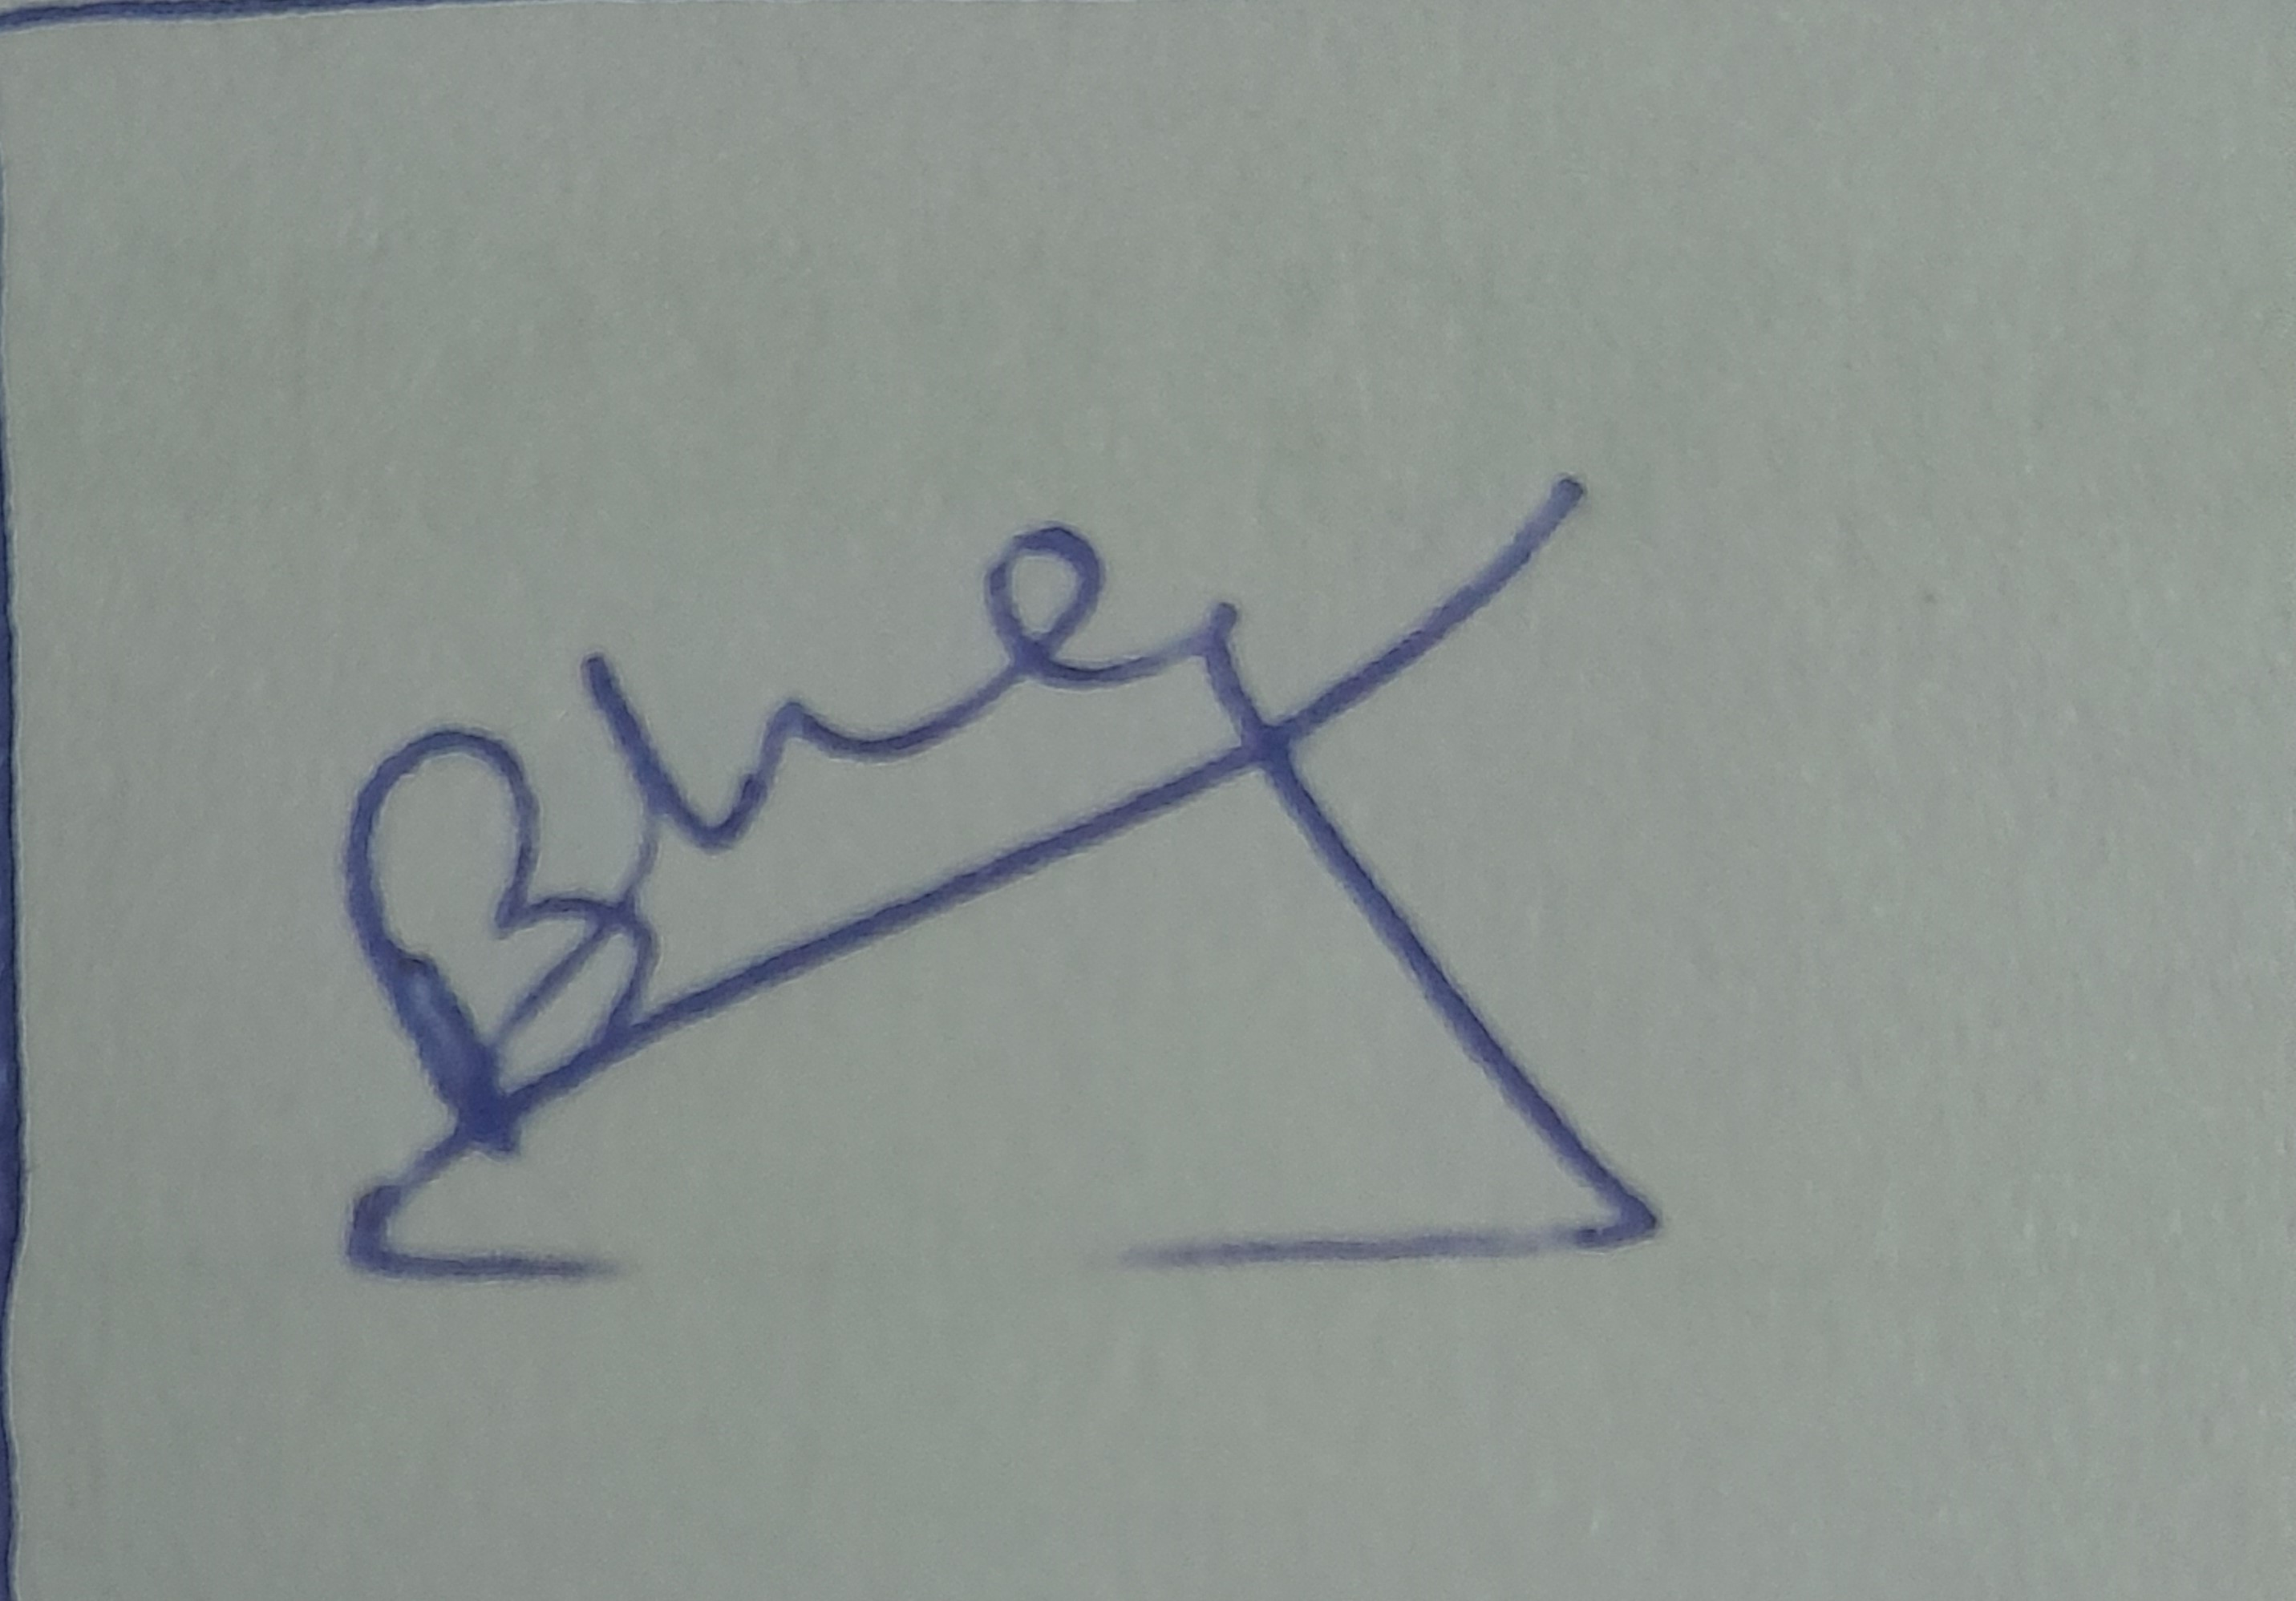 Date:17/02/2022

The information you have given above will be treated in strict confidence.

**Important: Data Protection Act (1998) or any equivalent local legislation.** This form asks you to supply “personal” data as defined by the Data Protection Act 1998. You will be supplying this data to the appropriate Security authority where it may be processed exclusively for the purpose of a check against the National Collection of Criminal Records. The Security authority will protect the information which you provide and will ensure that it is not passed to anyone who is not authorised to see it.

By signing the declaration on this form, you are explicitly consenting for the data you provide to be processed in the manner described above. If you have any concerns, about any of the questions or what we will do with the information you provide, please contact the person who issued this form for further information.